





Store with IPFS – Decentralized File Upload
Objective/Aim:
To implement a decentralized file upload system using IPFS (InterPlanetary File System) and Pinata, enabling permanent and censorship-resistant file storage on the decentralized web.

Apparatus/Software Used:
• Pinata API
• React (Frontend)
• IPFS (via Pinata gateway)
• Axios
• FormData
- Node.js

Theory/Concept:

IPFS is a decentralized file system that stores files using unique content hashes instead of URLs. Pinata is a service that helps keep these files available by “pinning” them. In this project, we built a React frontend and a Node.js backend to upload files to IPFS via Pinata and retrieve their IPFS hash for decentralized access.

Procedure:

- Set up Backend using Node.js and Express.
  - Install dependencies: axios, form-data, multer, dotenv, cors.
  - Create API route /upload to handle file uploads.
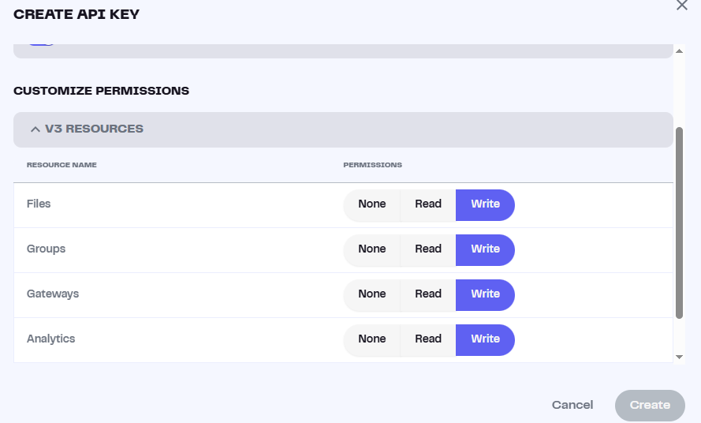
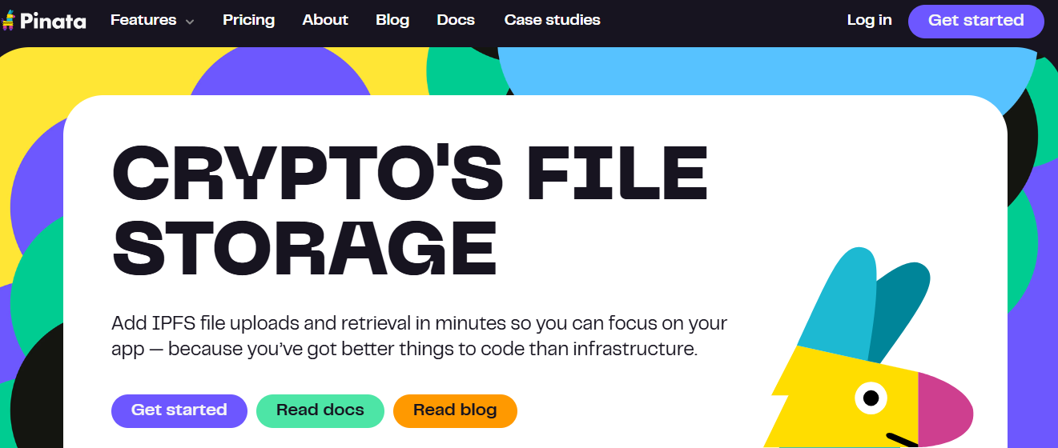
  - Use Pinata API to pin files to IPFS.
- Create Frontend using React (Vite or CRA).
  - Add a file input and upload button in App.jsx.
  - On submit, send the file to the backend using fetch and FormData.
- Connect Backend and Frontend.
  - Ensure CORS is enabled on backend.
  - Frontend sends file to backend at http://localhost:3000/upload.
- Display IPFS Hash.
  - Backend returns the IPFS hash after successful upload.
  - Show the hash and a link to access the file via IPFS gateway.

Observation:

